UNIT 3
Topic as per syllabus | As per Text Book
Synchronization: Background, Critical Section Problem, Mutex locks,  Semaphores, Classic Problems of Synchronization | Chapter 5 Process Synchronization  5.1 Background  5.2 The Critical-Section Problem  5.5 Mutex Locks  5.6 Semaphores  5.7 Classic Problems of Synchronization
Deadlocks: System Model, Deadlock characterization, Methods for handling  deadlocks, Deadlock prevention, Deadlock avoidance, Deadlock Detection  and Recovery from deadlock | Chapter 7 Deadlocks  7.1 System Model 315  7.2 Deadlock Characterization 317  7.3 Methods for Handling Deadlocks 322  7.4 Deadlock Prevention 323  7.5 Deadlock Avoidance 327  7.6 Deadlock Detection 333  7.7 Recovery from Deadlock 337

Chapter 7 Deadlocks

Introduction:
Deadlocks in operating systems occur when processes are unable to proceed because they are waiting for resources held by other processes, resulting in a system standstill. The system model describes how processes interact with resources, often utilizing resource allocation graphs to analyze potential deadlocks. Deadlock characterization identifies the four essential conditions for deadlock: mutual exclusion, hold-and-wait, no preemption, and circular wait.
To manage deadlocks, operating systems implement several strategies:

    - Prevention, which ensures that at least one of the conditions for deadlock cannot be met.
    - Avoidance, which dynamically maintains the system in a safe state (e.g., using the Banker's Algorithm).
    - Detection, which identifies deadlocks when they occur using tools such as wait- for graphs.
    - Recovery, which resolves deadlocks through process termination or resource preemption.
These strategies collectively help maintain efficient resource management and prevent system inefficiencies.

System Model:
A system consists of a finite number of resources distributed among competing processes. These resources are grouped into types, each with a certain number of identical instances.
Examples include memory space, CPU cycles, files, and I/O devices like printers. For instance, a system with two CPUs considers the CPU resource type to have two instances. Processes request resources before use and release them afterward, following a sequence of request, use, and release.
Deadlocks can arise when processes hold and wait for resources in a cycle, leading to a situation where none can proceed. Deadlocks may involve the same or different resource types, as seen in examples like competing printers or a printer and DVD drive.
To manage resources effectively, the system ensures proper allocation, tracks usage in system tables, and uses mechanisms like semaphores or mutex locks to handle resource requests and releases. Multithreaded applications are particularly prone to deadlocks due to shared resource competition, requiring careful programming to prevent them.

Deadlock Characterization:
Deadlocks in operating systems occur when a set of processes becomes indefinitely blocked because each process in the set is waiting for a resource held by another process. Four conditions must hold simultaneously for a deadlock to occur, collectively known as the necessary conditions for deadlock.
7.2.1 Necessary Conditions
A deadlock situation can arise if the following four conditions hold simultaneously in a system:

Mutual Exclusion
At least one resource involved must be held in a non-shareable mode, meaning only one process can use the resource at a time.

Example:
A printer being accessed by one process cannot be accessed by another process until it is released.

Hold and Wait
A process holding one or more resources can request additional resources without releasing the ones it already holds.

Example:
A process holding a printer requests access to a scanner while still holding the printer.

No Preemption
Resources cannot be forcibly taken away from a process; they must be released voluntarily by the process holding them.

Example:
A process using memory cannot be forced to release it for another process; it must finish its task and release it willingly.

Circular Wait
A set of processes exists in a circular chain where each process is waiting for a resource held by the next process in the chain.

Example:
  - Process P1 holds Resource R1 and requests Resource R2.
  - Process P2 holds Resource R2 and requests Resource R3.
  - Process P3 holds Resource R3 and requests Resource R1. This cycle causes a deadlock as no process can proceed. Example of Deadlock in an Operating System
Consider a system with two resources: a printer and a DVD drive.
  - Process P1 is holding the printer and requests the DVD drive.
  - Process P2 is holding the DVD drive and requests the printer. The processes are now in a deadlock state:
  - P1 cannot proceed because it is waiting for the DVD drive held by P2.
  - P2 cannot proceed because it is waiting for the printer held by P1.
This scenario satisfies all four necessary conditions for a deadlock, illustrating how resource contention can lead to system-wide blocking if not managed properly.
To mitigate deadlocks, operating systems implement techniques such as deadlock prevention, avoidance (e.g., Banker’s Algorithm), detection, and recovery, depending on the system’s design and requirements.

7.2.2 Resource-Allocation Graph

A Resource Allocation Graph (RAG) is a visual way to understand how resources are assigned in an operating system. Instead of using only tables to show which resources are allocated, requested or available, the RAG uses nodes and edges to clearly illustrate relationships between processes and their required resources.
- RAG shows which resources are allocated and which are requested by processes.
- It helps to visualize deadlocks more clearly than tables.
- RAG shows how allocation and requests affect the whole system.
- Processes = circles, Resources = squares and edges show allocation or request.
Types of Vertices in RAG
In a Resource Allocation Graph, there are two types of vertices
1. Process Vertex: Every process will be represented as a process vertex. Generally, the process will be represented with a circle.
2. Resource Vertex: Every resource will be represented as a resource vertex. It is also two types:

- Single Instance Resource: A resource with only one copy. In RAG, it is shown as a single node and only one process can use it at a time.
- Multi Instance Resource: A resource with multiple copies. In RAG, it is shown with multiple instances, so several processes can use different copies simultaneously.

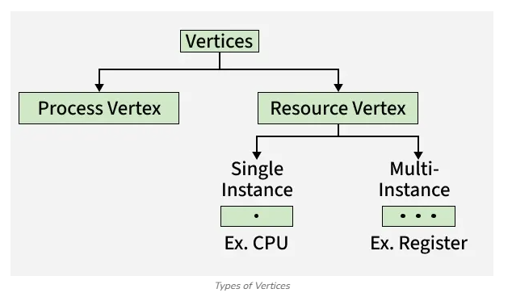

Types of Edges in RAG
There are two types of edges in RAG:

Assign Edge: If you already assign a resource to a process then it is called Assign edge. This is shown by an arrow from the resource vertex to the process vertex.
Request Edge: A request edge represents that a process is currently requesting a resource. This is shown by an arrow from the process vertex to the resource vertex.

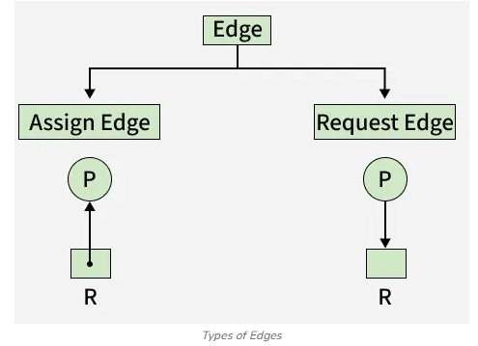

So, if a process is using a resource, an arrow is drawn from the resource node to the process node. If a process is requesting a resource, an arrow is drawn from the process node to the resource node

Example 1: (Single Instances RAG)

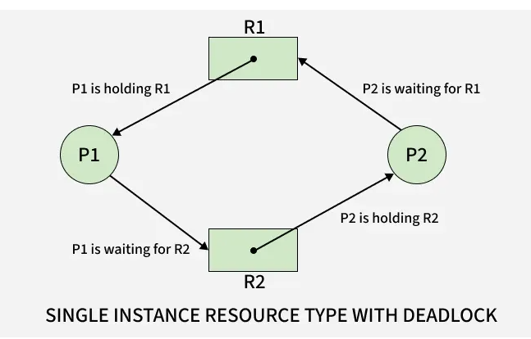

If there is a cycle in the Resource Allocation Graph and each resource in the cycle provides only one instance, then the processes will be in deadlock. For example, if process P1 holds resource R1, process P2 holds resource R2 and process P1 is waiting for R2 and process P2 is waiting for R1, then process P1 and process P2 will be in deadlock.

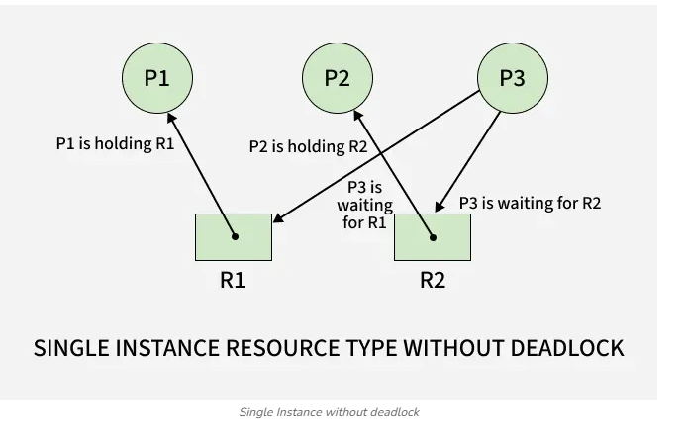

Here's another example, that shows Processes P1 and P2 acquiring resources R1 and R2 while process P3 is waiting to acquire both resources. In this example, there is no deadlock because there is no circular dependency. In Single Instances, a cycle in the graph is both a necessary and a sufficient condition for the existence of deadlock.

Example 2: (Multi-instances RAG)

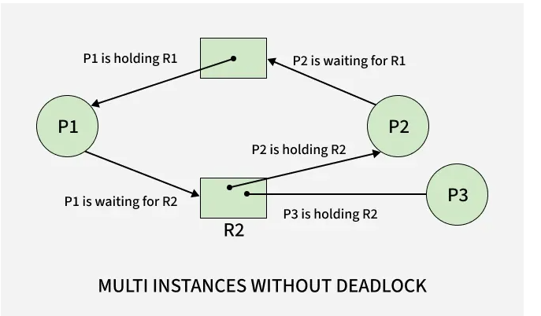

From the above example, it is not possible to say the RAG is in a safe state or in an unsafe state. So to see the state of this RAG, let's construct the allocation matrix and request matrix.

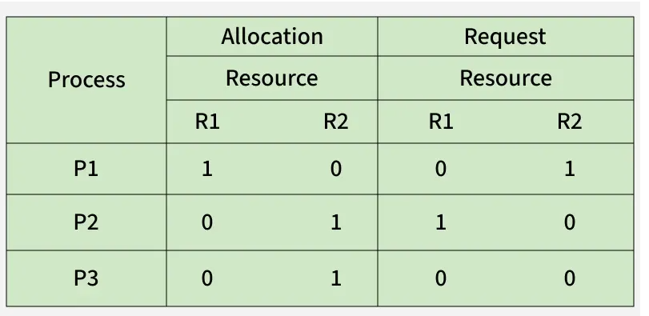

The total number of processes are three: P1, P2 & P3 and the total number of resources are two: R1 & R2.
Allocation matrix: For constructing the allocation matrix, just go to the resources and see to which process it is allocated.
R1 is allocated to P1, therefore write 1 in allocation matrix and similarly, R2 is allocated to P2 as well as P3 and for the remaining element just write 0.
Request matrix: In order to find out the request matrix, you have to go to the process and see the outgoing edges.
P1 is requesting resource R2, so write 1 in the matrix and similarly, P2 requesting R1 and for the remaining element write 0.
So now available resource is = (0, 0).
Checking deadlock (safe or not)
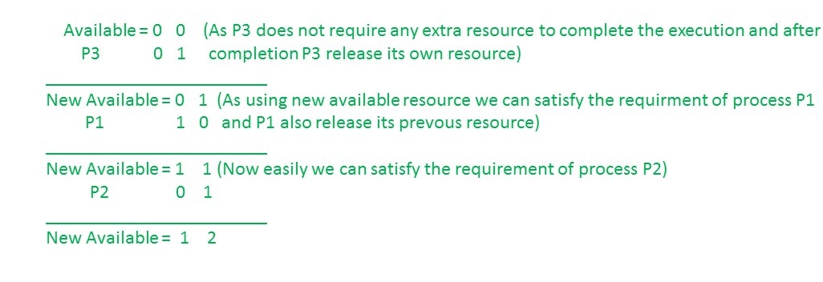
So there is no deadlock in this RAG. Even though there is a cycle, still there is no deadlock.
In the case of Multi-instances, a cycle in the graph is a necessary but not a sufficient condition for the existence of deadlock.

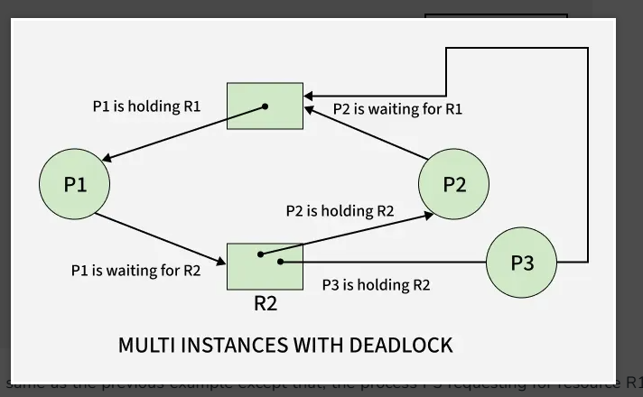

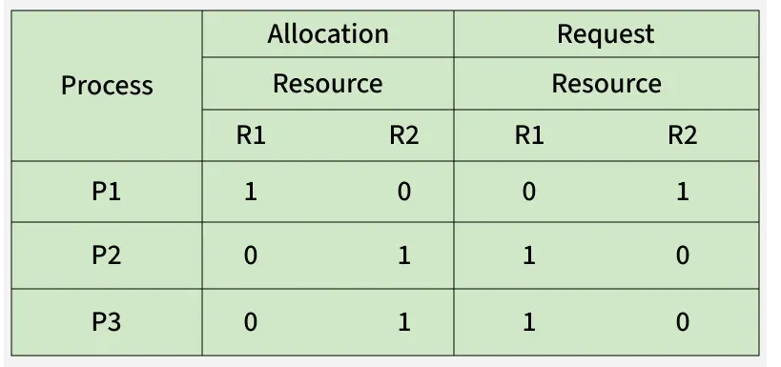

So, the Available resource is = (0, 0), but requirement are (0, 1), (1, 0) and (1, 0). So you can't fulfill any one requirement. Therefore, it is in deadlock. Therefore every cycle in a multi-instance resource type graph is not a deadlock. If there has to be a deadlock, there has to be a cycle. So in case of RAG with multi-instance resource type, the cycle is a necessary condition for deadlock but not sufficient.

Deadlock Detection using Resource Allocation Graph
A Resource Allocation Graph (RAG) is used to detect deadlocks by analyzing the relationships between processes and resources in a system. It visually represents how resources are allocated and requested.

If graph contains no cycles no deadlock.
If graph contains a cycle if only one instance per resource type, then deadlock.
If graph contains a cycle if several instances per resource type, possibility of deadlock

Example 3: (Multi-instances RAG)

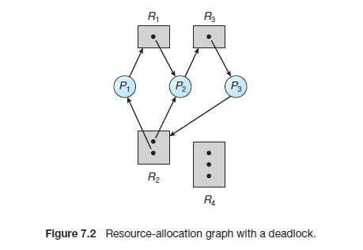
Process | Allocation R1 | Allocation R2 | Allocation R3 | Request R1 | Request R2 | Request R3
P1 | 0 | 1 | 0 | 1 | 0 | 0
P2 | 1 | 1 | 0 | 0 | 0 | 1
P3 | 0 | 0 | 1 | 0 | 1 | 0

Available=(0,0,0)
Step | Process Selected | Request | Available Before Execution | Condition Check | Allocation Released After Completion | Available After Completion
1 | P1 | (1,0,0) | (0,0,0) | (1,0,0) ≤ (0,0,0) ✘ | — | (0,0,0)
2 | P2 | (0,0,1) | (0,0,0) | (0,0,1) ≤ (0,0,0) ✘ | — | (0,0,0)
3 | P3 | (0,1,0) | (0,0,0) | (0,1,0) ≤ (0,0,0) ✘ | — | (0,0,0)

The system is in a DEADLOCK STATE.
❌ No safe sequence exists because all processes are permanently waiting for each other.

Example 4: (Multi-instances RAG)

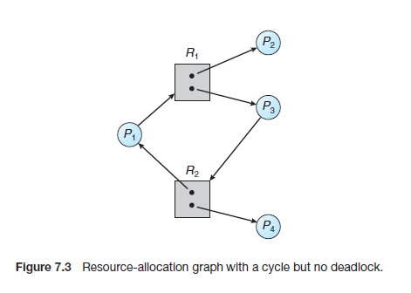

1. Allocation and Request Table
Process | Allocation R1 | Allocation R2 | Request R1 | Request R2
P1 | 0 | 1 | 1 | 0
P2 | 1 | 0 | 0 | 0
P3 | 1 | 0 | 0 | 1
P4 | 0 | 1 | 0 | 0

2. Step-by-Step Analysis
Step | Process | Request | Available Before | Can Execute? | Allocation Released After Completion | Available After Completion
1 | P2 | (0,0) | (0,0) | ✔ Yes | (1,0) | (1,0)
2 | P1 | (1,0) | (1,0) | ✔ Yes | (0,1) | (1,1)
3 | P3 | (0,1) | (1,1) | ✔ Yes | (1,0) | (2,1)
4 | P4 | (0,0) | (2,1) | ✔ Yes | (0,1) | (2,2)

3. Cycle Present in the Graph
The graph contains the cycle:
P1 → R1 → P3 → R2 → P1
However, deadlock does not occur because process P2 can complete first and release R1.
Once R1 becomes free, P1 can execute and release R2. Then P3 can proceed successfully.

4. Final Conclusion
Although a cycle exists in the Resource Allocation Graph, the system is NOT in deadlock state.

Methods for Handling Deadlocks:
Generally speaking, we can deal with the deadlock problem in one of three
ways:
• We can use a protocol to prevent or avoid deadlocks, ensuring that the
system will never enter a deadlocked state.
• We can allow the system to enter a deadlocked state, detect it, and recover.
• We can ignore the problem altogether and pretend that deadlocks never occur in the system.
Many operating systems, including Linux and Windows, choose to ignore deadlocks, relying on application developers to handle them. This approach is cost-effective but can result in system performance degradation if deadlocks do occur. Some systems combine these methods to address various resource allocation problems and select the optimal strategy for different types of resources.

Deadlock Prevention:
Deadlock is a situation in an operating system where a set of processes is stuck because each process is waiting for a resource that another process in the set holds. Deadlock prevention is one of the strategies to handle deadlocks by ensuring that at least one of the necessary conditions for deadlock does not hold.

Necessary Conditions for Deadlock
For a deadlock to occur, the following four conditions must hold simultaneously:

Mutual Exclusion:
At least one resource must be held in a non-shareable mode.

Hold and Wait:
A process holding at least one resource is waiting for additional resources held by other processes.

No Preemption:
Resources cannot be forcibly taken from a process; they can only be released voluntarily.

Circular Wait:
A set of processes is waiting in a circular chain, where each process waits for a resource held by the next process.

Deadlock Prevention Techniques
To prevent deadlocks, the system ensures that at least one of the necessary conditions never holds. Here are the strategies:

Mutual Exclusion Prevention
  - Avoid making resources exclusively available.
  - For example, using spooling for resources like printers. Instead of giving the printer directly to a process, the output is written to a spool and printed sequentially.

Limitation:
Not all resources can be shared (e.g., semaphores or mutex locks).

Hold and Wait Prevention
  - Ensure that a process requests all required resources at once, or it releases all held resources before requesting additional resources.
  - Example: In a banking application, a process may request access to multiple accounts simultaneously rather than one at a time.

Drawback:
This can lead to low resource utilization, as processes may hold resources they do not need immediately.

No Preemption Prevention
  - Allow resources to be forcibly taken away if the requesting process cannot proceed otherwise.
  - Example: In CPU scheduling, if a higher-priority process arrives, the CPU may be preempted from the currently running process.

Limitation:
Implementing preemption may not be feasible for all types of resources (e.g., files being modified).

Circular Wait Prevention
  - Impose a total ordering on resources and require that processes request resources in increasing order.
  - Example: If resources R1, R2, R3are ordered, a process holding R1can only request R2 orR3, and not R0.

Drawback:
This may lead to inefficiencies and may require significant changes in resource allocation.

Example of Deadlock Prevention
Consider a system with two processes P1 and P2, and two resources R1 and R2:
  - Deadlock Scenario: P1 holds R1 and requests R2, while P2 holds R2 and requests R1. A circular wait occurs, leading to deadlock.
  - Circular Wait Prevention: By assigning an order to resources, say R1<R2 the processes must request resources in that order. If P1 requests R2, it must first release R1. This breaks the circular wait condition.
Deadlock prevention involves compromising on one or more of the four necessary conditions for deadlock. While effective, these strategies often lead to reduced resource utilization or increased complexity. Hence, a balance between prevention and performance must be achieved.

Deadlock Avoidance:
Deadlock avoidance is a strategy for handling deadlocks in an operating system. It ensures that the system will never enter an unsafe state, where deadlock becomes possible. Unlike deadlock prevention, which restricts resource allocation policies, avoidance requires additional runtime information to make decisions about resource allocation.
Deadlock avoidance requires advance information about the order in which processes request and release resources. Using this information, the operating system checks resource availability, current allocations, and future requests before granting a request, so that future deadlocks can be avoided.
Deadlock-avoidance algorithms differ based on the type and amount of information they require. The simplest approach requires each process to declare the maximum number of resources it may need in advance. Using this information, the operating system dynamically checks the resource-allocation state to ensure that the system never enters a deadlock state. The resource-allocation state includes available resources, allocated resources, and the maximum demands of processes.

Safe and Unsafe States
    - Safe State:
A state where the system can allocate resources to all processes in some order without entering a deadlock.
A system is said to be in a safe state if resources can be allocated to all processes in some order without causing deadlock. Such an order is called a safe sequence. In a safe sequence, each process can obtain its required resources using the currently available resources along with the resources released by previously completed processes. After a process finishes execution, it releases its resources, allowing the next process in the sequence to proceed safely.

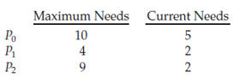
A safe state is a state where the system can allocate resources to processes without causing deadlock, whereas a deadlocked state is always unsafe. However, not every unsafe state results in deadlock; an unsafe state only indicates the possibility of deadlock in the future. In a safe state, the operating system can prevent deadlock by carefully allocating resources, but in an unsafe state, future process requests may lead to deadlock. For example, consider a system with twelve tape drives and three processes P0, P1, and P2. At a particular time, P0 holds five tape drives, P1 holds two, and P2 holds two, leaving three tape drives free in the system.
At time t0, the system is in a safe state because there exists a safe sequence <P1, P0, P2>. Process P1 can complete first and release its resources, followed by P0 and then P2, allowing all processes to finish without deadlock. However, a system can move from a safe state to an unsafe state. At time t1, when process P2 is allocated one additional tape drive, the system becomes unsafe because future requests from P0 and P2 may not be satisfied, leading to deadlock. The deadlock could have been avoided if P2 had waited until another process completed and released its resources. Deadlock-avoidance algorithms therefore ensure that the system always remains in a safe state by granting a resource request only if the resulting state is safe. In this approach, even if resources are available, a process may still have to wait, which can reduce resource utilization

1. Introduction
This example explains how Banker’s Algorithm determines whether a system is in a SAFE STATE or an UNSAFE STATE. The system contains 12 tape drives and three processes P0, P1, and P2. Each process has a maximum resource requirement, current allocation, and remaining need.

2. Maximum Resource Requirement
Process | Maximum Requirement
P0 | 10
P1 | 4
P2 | 9

3. Initial Allocation at Time t0
Process | Allocated Resources | Need
P0 | 5 | (10-5)=5
P1 | 2 | (4-2)=2
P2 | 2 | 9-2=7
Available tape drives are calculated as:
Available = 12 - (5 + 2 + 2) = 3

4. Safe State at Time t0
Step | Process Executed | Allocated | Need | Available Before Execution | Can Execute?  Need<available | Remaining after need | Resources Released After Completion  Allocated + need | New Available  Remaining + released
1 | P1 | 2 | 2 | 3 | Yes | 3-2 =1 | 4 (2+2) | 5 (1+4)
2 | P0 | 5 | 5 | 5 | Yes | 5-5=0 | 10 (5+5) | 10 (0+10)
3 | P2 | 2 | 7 | 10 | Yes | 10-7=3 | 9 (2+7) | 12 (3+9)
At time t0, the system is in SAFE STATE because a safe sequence exists.

5. Safe Sequence
<P1, P0, P2>

6. System Changes to Time t1
After some time, process P2 requests one additional tape drive. The operating system grants the request.
Process | Allocated Resources at t1
P0 | 5
P1 | 2
P2 | 3
Now available tape drives become:
Available = 12 - (5 + 2 + 3) = 2

7. Unsafe State at Time t1
At time t1, the system enters an UNSAFE STATE.
Process | Remaining Need | Available Resources | Can Execute?
P1 | 2 | 2 | Yes
P0 | 5 | 2 | No
P2 | 6 | 2 | No
Only process P1 can complete. After P1 finishes, available resources become 4. However, P0 still requires 5 tape drives and P2 still requires 6 tape drives. Therefore, no safe sequence exists.

8. Final Conclusion
At time t0, the system is in SAFE STATE because all processes can complete in the sequence <P1, P0, P2>. After granting one additional tape drive to P2 at time t1, the system enters an UNSAFE STATE because no safe sequence exists.

    - Resource-Allocation-Graph Algorithm
The Resource-Allocation-Graph Algorithm is a deadlock-avoidance technique used when each resource type has only one instance. It uses claim edges to represent future resource requests and prevents deadlock by ensuring that resource allocation never creates a cycle in the graph.
The operating system checks every resource request before allocation. Before assigning a resource to a process, the system verifies whether the allocation will create a cycle in the graph. If a cycle is formed, the resource is not allocated because a cycle may lead to deadlock. If no cycle is formed, the resource allocation is considered safe and is allowed.
1. Introduction
The Resource-Allocation-Graph (RAG) Algorithm is a deadlock avoidance algorithm used when each resource type has only one instance. The operating system checks whether allocating a resource will create a cycle in the graph. If a cycle forms, the request is denied to avoid deadlock.
Types of Edges in RAG
Edge Type | Representation | Meaning
Request Edge | Pi → Rj | Process Pi is requesting resource Rj
Assignment Edge | Rj → Pi | Resource Rj is allocated to process Pi
Claim Edge | Pi → Rj (dashed) | Process Pi may request resource Rj in future
Claim Edge Concept
Claim edges are represented using dashed lines. They indicate that a process may request a resource in the future.
All claim edges must be added before the process begins execution. This helps the operating system predict future requests and avoid unsafe allocations.
Working of the Algorithm
Initially, claim edges exist between processes and resources.
When a process requests a resource, the claim edge becomes a request edge.
If the request is granted, the request edge becomes an assignment edge.
When the process releases the resource, the assignment edge changes back into a claim edge.
Before allocation, the OS checks whether a cycle will form.
If a cycle forms, the request is denied to avoid deadlock.
Initial Graph with Claim Edges
In the following graph, the dashed edges represent claim edges.
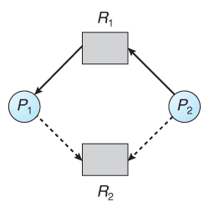
Here, process P1 may request resource R2 in the future. Similarly, process P2 may also request R2 later.
When P2 Requests R2
Suppose process P2 now requests resource R2. The claim edge becomes a request edge and the resource is allocated.
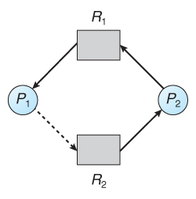
After allocation, the operating system checks whether a cycle exists in the graph.
If a cycle forms, the request is denied because the system may enter deadlock.
Important Concept
The Resource-Allocation-Graph Algorithm avoids deadlock by preventing cycles from forming.
Cycle in Graph + Single Instance Resource = Possible Deadlock
The RAG Algorithm uses claim edges to predict future resource requests. Before granting a resource, the OS checks whether allocation creates a cycle. If no cycle forms, allocation is allowed; otherwise, the request is denied.

2. Conversion of Edges
Initially, the graph contains claim edges. When a process actually requests a resource, the claim edge is converted into a request edge.
P1 → R1
If the operating system determines that granting the resource is safe, the request edge becomes an assignment edge.
R1 → P1
When the process finishes using the resource and releases it, the assignment edge changes back into a claim edge.
P1 ---→ R1
Thus, the graph changes dynamically during execution.

3. Dynamic Edge Conversion Flow
Claim Edge
↓
Request Edge
↓
Assignment Edge
↓
Release Resource
↓
Claim Edge again

    - Banker’s Algorithm( deadlock avoidance algorithm)
- The Resource-Allocation-Graph algorithm works only when each resource type has a single instance.
- It cannot be used in systems with multiple instances of resources such as multiple printers, memory blocks, or tape drives.
- For such systems, the operating system uses the Banker’s Algorithm for deadlock avoidance.
- Banker’s Algorithm is less efficient than the Resource-Allocation-Graph algorithm but can handle multiple resource instances.
- The algorithm checks whether allocating requested resources keeps the system in a safe state.
- Resources are allocated only if the system remains safe after allocation; otherwise, the process must wait.
- The name “Banker’s Algorithm” comes from the banking system analogy.
- Just like a bank carefully allocates cash so that it can satisfy all customers later, the operating system allocates resources carefully to avoid deadlock.

There are various data structures which are used to implement this algorithm.

Data Structures used to implement Banker’s Algorithm
- Available: It is a 1-D array that tells the number of each resource type (instance of resource type) currently available. Example: Available[R1]= A, means that there are A instances of R1 resources are currently available.
- Max: It is a 2-D array that tells the maximum number of each resource type required by a process for successful execution. Example: Max[P1][R1] = A, specifies that the process P1 needs a maximum of A instances of resource R1 for complete execution.
- Allocation: It is a 2-D array that tells the number of types of each resource type that has been allocated to the process. Example: Allocation[P1][R1] = A, means that A instances of resource type R1 have been allocated to the process P1.
- Need: It is a 2-D array that tells the number of remaining instances of each resource type required for execution. Example: Need[P1][R1]= A tells that A instances of R1 resource type are required for the execution of process P1.

Need[i][j]= Max[i][j] - Allocation[i][j], where i corresponds any process P(i) and j corresponds to any resource type R(j)

1. Banker’s Algorithm Data Structures
Data Structure | Type | Meaning
Available | 1-D Array | Tells the number of available instances of each resource type
Max | 2-D Array | Maximum resources each process may need
Allocation | 2-D Array | Resources currently allocated to each process
Need | 2-D Array | Remaining resources required by each process

Example for Banker’s Algorithm
Suppose the system has:
• 2 Resource Types → R1 and R2
• 3 Processes → P0, P1, P2

Total Resources in System
Resource Type | Total Instances
R1 | 10
R2 | 5

Max, Allocation and Need Matrices
Process | Max | Allocation | Need
P0 | (7,5) | (3,2) | (4,3)
P1 | (3,2) | (1,0) | (2,2)
P2 | (9,2) | (2,1) | (7,1)

Formula Used
Need = Max − Allocation

Available Calculation after Allocation
For R1:
10 − (3 + 1 + 2) = 4
For R2:
5 − (2 + 0 + 1) = 2
Therefore, Available = (4,2)

Available Vector (1-D Array)
Resource Type | Available Instances
R1 | 4
R2 | 2
Available = (4,2)

The Bankers Algorithm consists of the following two algorithms
- Request-Resource Algorithm
- Safety Algorithm

      - Safety Algorithm
We can now present the algorithm for finding out whether or not a system is in a safe state. This algorithm can be described as follows:
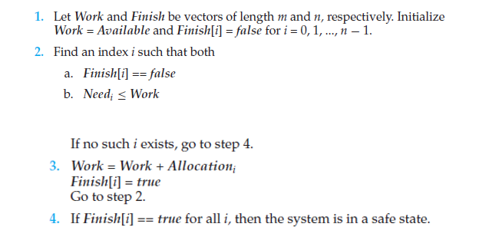

Safety Algorithm Example – Banker’s Algorithm
Initial System Resources:
R1 = 6 instances
R2 = 3 instances

Process | Allocation (R1,R2) | Need (R1,R2) | Finish Initially
P0 | (1,0) | (1,1) | False
P1 | (1,1) | (2,1) | False
P2 | (1,0) | (1,0) | False

Resource | Total Instances | Available Resources
R1 | 6 | 3
R2 | 3 | 2

Work=Available=(3,2)

Safety Algorithm Execution
Step No | Process Selected | Need | Work Before | Need ≤ Work | Allocation Released | Work + Allocation | Finish Before | Finish After
1 | P0 | (1,1) | (3,2) | Yes | (1,0) | (4,2) | False | True
2 | P1 | (2,1) | (4,2) | Yes | (1,1) | (5,3) | False | True
3 | P2 | (1,0) | (5,3) | Yes | (1,0) | (6,3) | False | True

Final Result
Safe Sequence = <P0, P1, P2>
All Finish values become TRUE.
Therefore, the SYSTEM IS IN SAFE STATE.

      - Resource-Request Algorithm

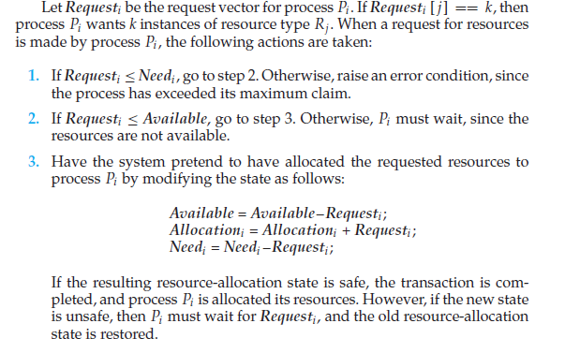

Safety and Request-Resource Algorithm – Banker’s Algorithm
Process | Allocation (R1,R2) | Max (R1,R2) | Need (R1,R2)
P0 | (3,1) | (7,3) | (4,2)
P1 | (2,1) | (3,2) | (1,1)
P2 | (2,1) | (9,2) | (7,1)

Resource Type | Total Instances | Allocated | Available
R1 | 10 | 7 | 3
R2 | 5 | 3 | 2

Step | Available Before Execution | Process Selected | Need of Process | Condition Check | Allocation Released | Available After Execution
1 | (3,2) | P1 | (1,1) | (1,1) ≤ (3,2) ✔ | (2,1) | (5,3)
2 | (5,3) | P0 | (4,2) | (4,2) ≤ (5,3) ✔ | (3,1) | (8,4)
3 | (8,4) | P2 | (7,1) | (7,1) ≤ (8,4) ✔ | (2,1) | (10,5)

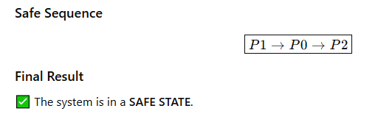

Request by Process P1 Request1​= (1,1)

Parameter | Previous P1 Value | Operation | New P1 Value
Allocation₁ | (2,1) | (2,1) + (1,1) | (3,2)
Need₁ | (1,1) | (1,1) − (1,1) | (0,0)
Available | (3,2) | (3,2) − (1,1) | (2,1)
Previous values
Process | Allocation (R1,R2) | Max (R1,R2) | Need (R1,R2)
P0 | (3,1) | (7,3) | (4,2)
P1 | (2,1) | (3,2) | (1,1)
P2 | (2,1) | (9,2) | (7,1)
New Values with available = (2,1)
Process | Updated Allocation (R1,R2) | Updated Need (R1,R2)
P0 | (3,1) | (4,2)
P1 | (3,2) | (0,0)
P2 | (2,1) | (7,1)

Step | Available Before Execution | Process Selected | Need of Process | Condition Check | Allocation Released | Available After Execution
1 | (2,1) | P1 | (0,0) | (0,0) ≤ (2,1) ✔ | (3,2) | (5,3)
2 | (5,3) | P0 | (4,2) | (4,2) ≤ (5,3) ✔ | (3,1) | (8,4)
3 | (8,4) | P2 | (7,1) | (7,1) ≤ (8,4) ✔ | (2,1) | (10,5)
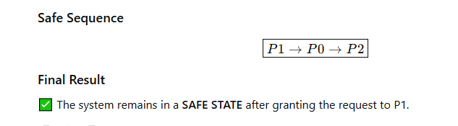

Example: Considering a system with five processes P₀ through P₄ and three resources of type A, B, C. Resource type A has 10 instances, B has 5 instances and type C has 7 instances. Suppose at time t₀ following snapshot of the system has been taken:

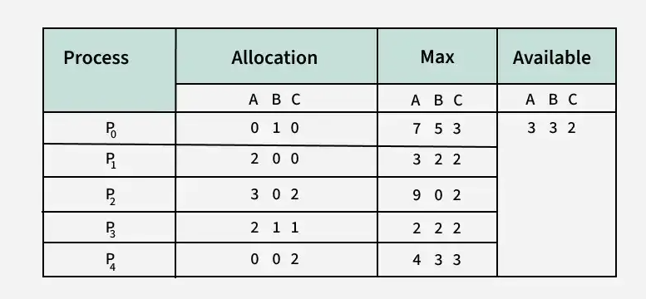

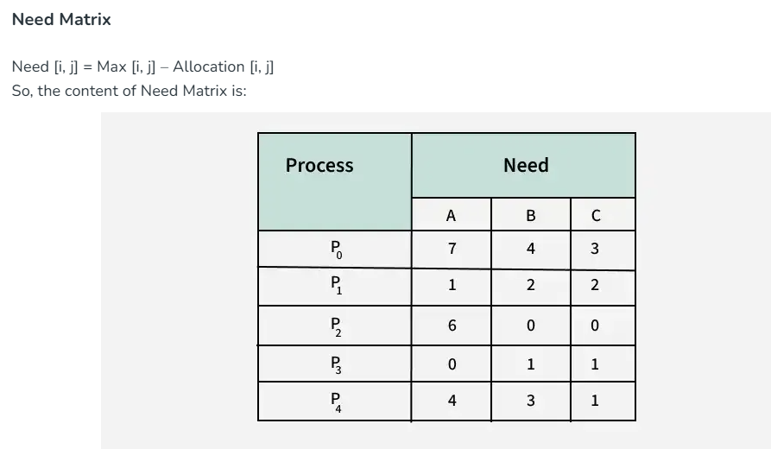

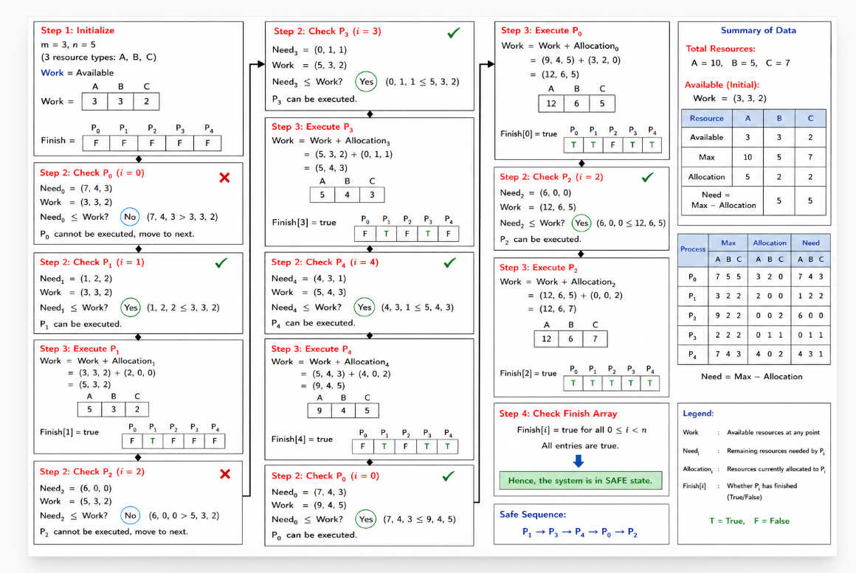

Step | Process | Need | Work Before | Need ≤ Work? | Allocation Released | New Work | Finish
1 | P1 | (1,2,2) | (3,3,2) | Yes | (2,0,0) | (5,3,2) | F T F F F
2 | P3 | (0,1,1) | (5,3,2) | Yes | (2,1,1) | (7,4,3) | F T F T F
3 | P4 | (4,3,1) | (7,4,3) | Yes | (0,0,2) | (7,4,5) | F T F T T
4 | P0 | (7,4,3) | (7,4,5) | Yes | (0,1,0) | (7,5,5) | T T F T T
5 | P2 | (6,0,0) | (7,5,5) | Yes | (3,0,2) | (10,5,7) | T T T T T

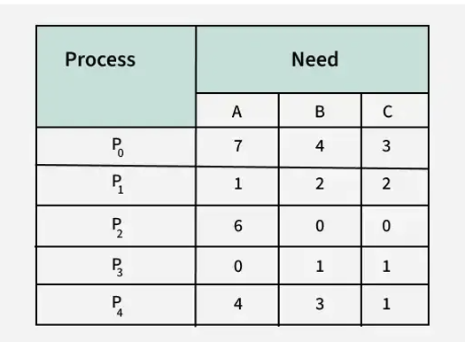
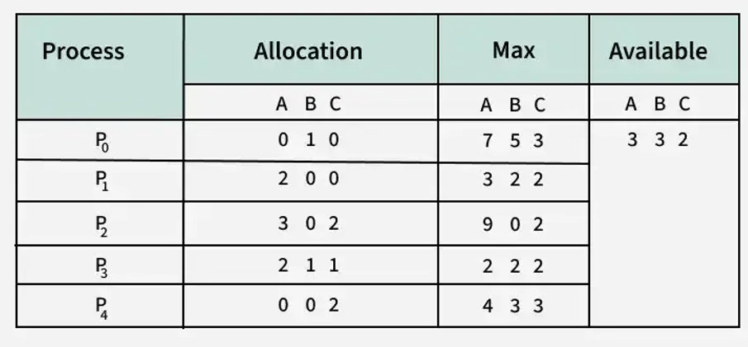

Safe State and Safe Sequence Analysis
Applying the Safety algorithm on the given system,

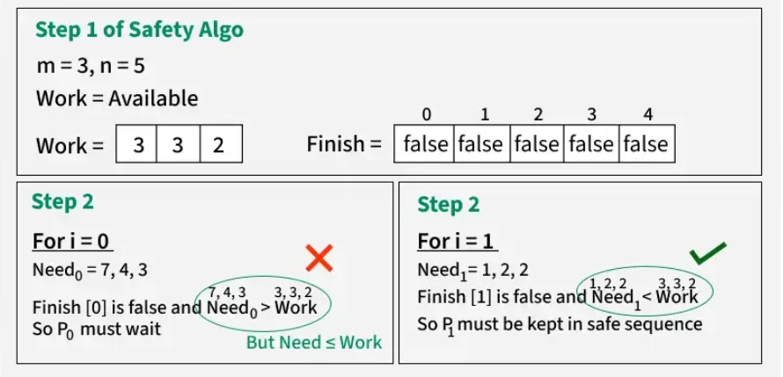

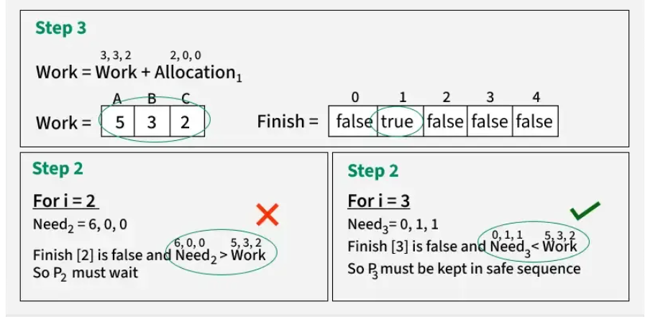

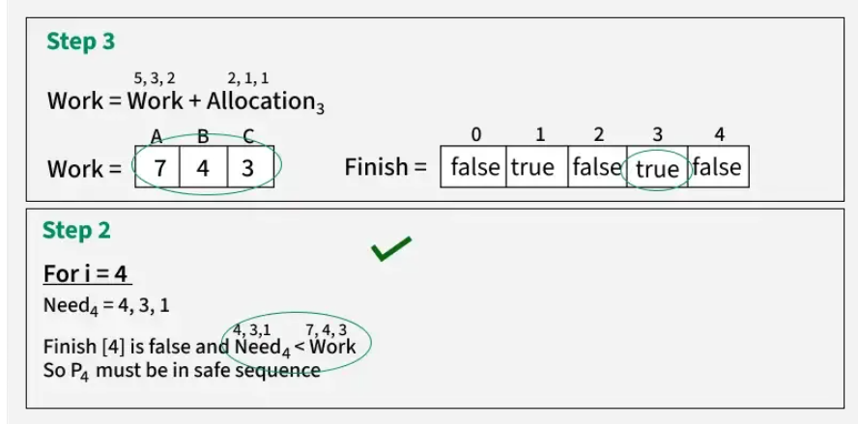

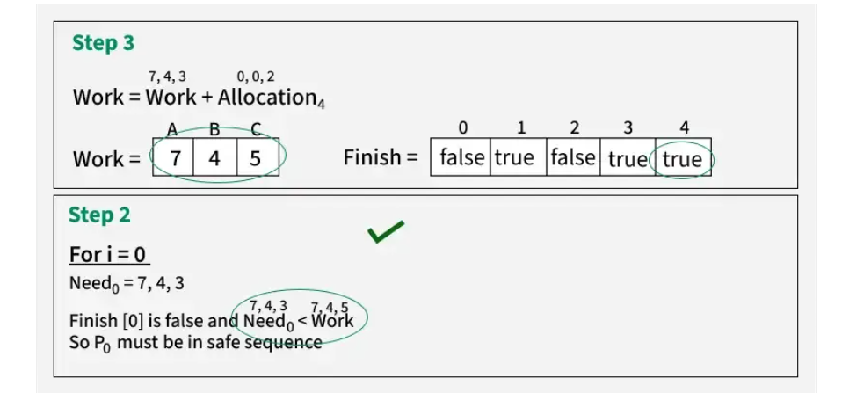

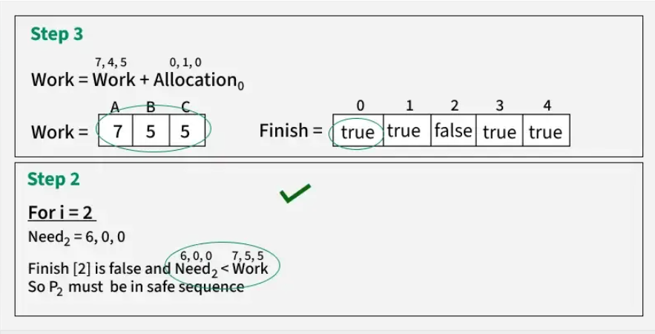

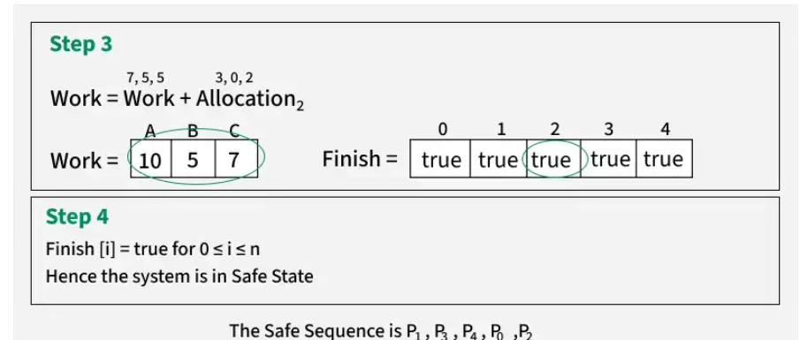

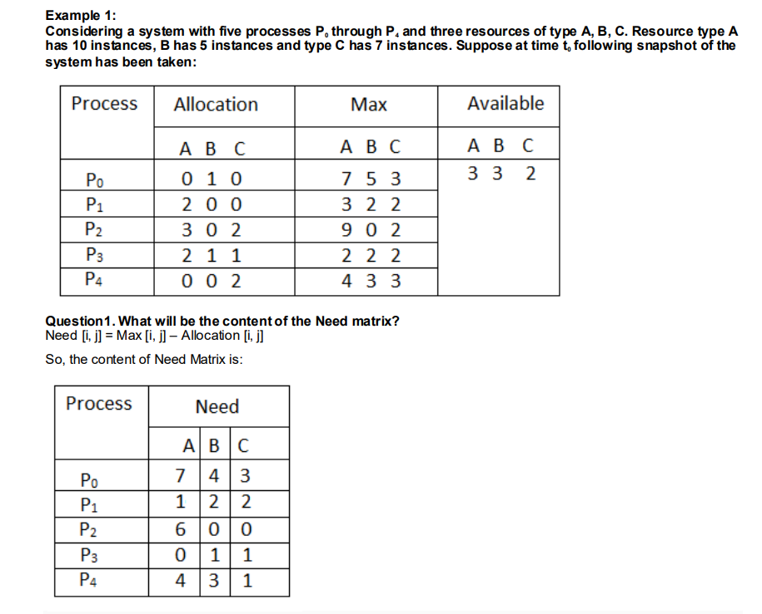

Suppose now that process

P1 requests one additional instance of resource type A and two instances of

resource type C, so Request1 = (1,0,2).

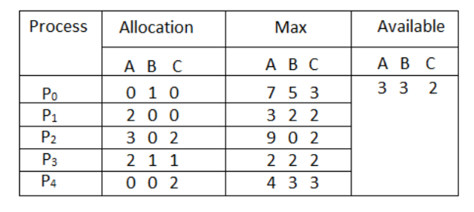

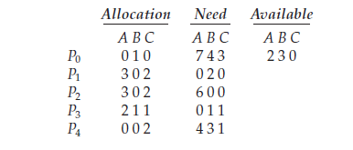
Old Values
Step | Parameter | Previous Value | Condition / Operation | New Value | Result
1 | Request₁ vs Need₁ | Request₁ = (1,0,2) Need₁ = (1,2,2) | (1,0,2) ≤ (1,2,2) | TRUE | Request is within Need ✔
2 | Request₁ vs Available | Request₁ = (1,0,2) Available = (3,3,2) | (1,0,2) ≤ (3,3,2) | TRUE | Resources are Available ✔
3 | Allocation₁ | (2,0,0) | (2,0,0) + (1,0,2) | (3,0,2) | Allocation Updated ✔
4 | Need₁ | (1,2,2) | (1,2,2) − (1,0,2) | (0,2,0) | Need Updated ✔
5 | Available | (3,3,2) | (3,3,2) − (1,0,2) | (2,3,0) | Available Updated ✔

Parameter | Previous P1 Value | Operation | New P1 Value
Allocation₁ | (2,0,0) | (2,0,0) + (1,0,2) | (3,0,2)
Need₁ | (1,2,2) | (1,2,2) − (1,0,2) | (0,2,0)
Available | (3,3,2) | (3,3,2) − (1,0,2) | (2,3,0)

Step | Available Before Execution | Process Selected | Need of Process | Condition Check | Allocation Released | Available After Execution
1 | (2,3,0) | P1 | (0,2,0) | (0,2,0) ≤ (2,3,0) ✔ | (3,0,2) | (5,3,2)
2 | (5,3,2) | P3 | (0,1,1) | (0,1,1) ≤ (5,3,2) ✔ | (2,1,1) | (7,4,3)
3 | (7,4,3) | P4 | (4,3,1) | (4,3,1) ≤ (7,4,3) ✔ | (0,0,2) | (7,4,5)
4 | (7,4,5) | P0 | (7,4,3) | (7,4,3) ≤ (7,4,5) ✔ | (0,1,0) | (7,5,5)
5 | (7,5,5) | P2 | (6,0,0) | (6,0,0) ≤ (7,5,5) ✔ | (3,0,2) | (10,5,7)

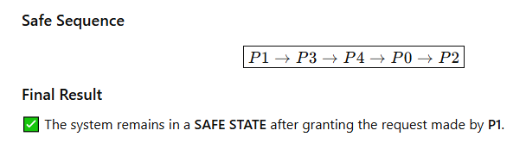

7.6 Deadlock Detection

If a system does not employ either a deadlock-prevention or a deadlock avoidance algorithm, then a deadlock situation may occur. In this environment, the system may provide:

7.6.1 Single Instance of Each Resource Type

Wait-For Graph

When each resource type has only one instance, deadlock detection can be performed using a Wait-For Graph.

A wait-for graph is created from the resource-allocation graph by removing resource nodes and directly connecting processes.

An edge from Pi to Pj means that process Pi is waiting for a resource currently held by process Pj.

Resource Allocation Graph and Wait-For Graph

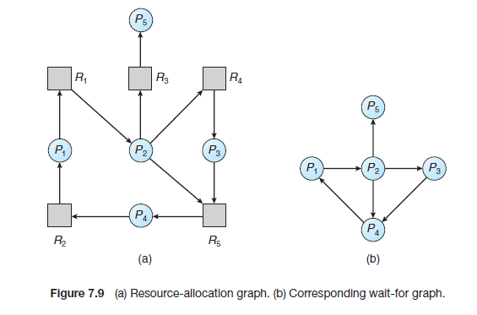

Figure (a) shows the Resource Allocation Graph (RAG). Figure (b) shows the corresponding Wait-For Graph obtained after removing resource nodes.

Important Point
Condition | Meaning
No cycle in Wait-For Graph | No deadlock
Cycle exists in Wait-For Graph | Deadlock exists

Example Understanding

Suppose process P1 is waiting for a resource held by process P2. Then the wait-for graph contains the edge:

P1 → P2

This indicates that P1 cannot proceed until P2 releases the required resource.

7.6.2 Several Instances of a Resource Type
The Wait-For Graph method cannot be used when a system contains multiple instances of each resource type. In such systems, a special deadlock detection algorithm is used.
This algorithm is similar to Banker’s Algorithm because it uses matrices and vectors to represent resource allocation and process requests.

Data Structures Used
Data Structure | Type | Meaning
Available | 1-D Vector | Indicates the number of available instances of each resource type
Allocation | n × m Matrix | Shows the number of resources currently allocated to each process
Request | n × m Matrix | Shows the current request of each process

Request Matrix
If Request[i][j] = k, then process Pi is requesting k more instances of resource type Rj.

Simple Example
Suppose:
Process | Allocation | Request | Meaning
P0 | (1,0) | (0,1) | P0 holds one R1 and requests one R2
P1 | (0,1) | (1,0) | P1 holds one R2 and requests one R1
The detection algorithm checks whether processes can complete using the currently available resources.

Vector Comparison
The relation:
Requesti ≤ Available
means that all requested resources of process Pi are available.

Working of Detection Algorithm
Initialize Work = Available
Initialize Finish[i] for all processes
Find a process whose Request ≤ Work
Allow the process to complete
Release its Allocation back to Work
Repeat until all processes finish or no process can proceed

Comparison with Banker’s Algorithm
Feature | Banker’s Algorithm | Detection Algorithm
Purpose | Avoid deadlock | Detect deadlock
When Used | Before allocation | After deadlock may occur
Need Matrix | Uses Need matrix | Uses Request matrix
Goal | Maintain safe state | Find deadlocked processes

Deadlock Detection Algorithm

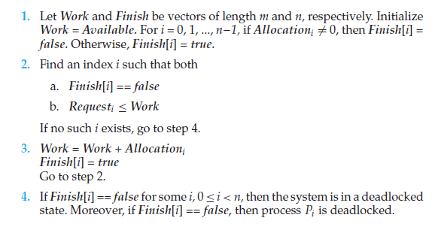

Given Data

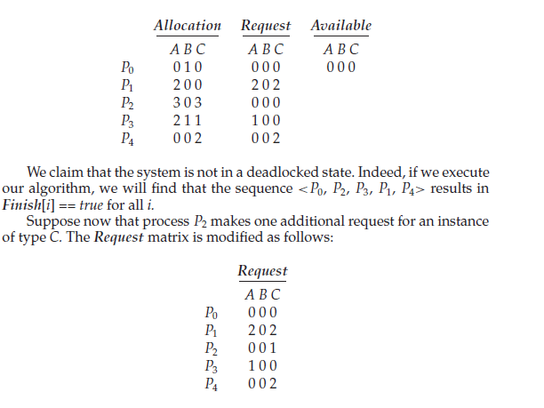

We use the Deadlock Detection Algorithm. The algorithm checks whether all processes can complete using the currently available resources.

Initial Values
Available | A | B | C
Work | 0 | 0 | 0
Finish Array Initialization:
P0 | P1 | P2 | P3 | P4
F | F | F | F | F

Step-by-Step Execution
Step | Process | Request | Work Before | Request ≤ Work? | Allocation Released | New Work | Finish
1 | P0 | (0,0,0) | (0,0,0) | Yes | (0,1,0) | (0,1,0) | T F F F F
2 | P2 | (0,0,0) | (0,1,0) | Yes | (3,0,3) | (3,1,3) | T F T F F
3 | P3 | (1,0,0) | (3,1,3) | Yes | (2,1,1) | (5,2,4) | T F T T F
4 | P1 | (2,0,2) | (5,2,4) | Yes | (2,0,0) | (7,2,4) | T T T T F
5 | P4 | (0,0,2) | (7,2,4) | Yes | (0,0,2) | (7,2,6) | T T T T T

Safe Sequence
<P0, P2, P3, P1, P4>
All Finish[i] values become TRUE.
Therefore, the system is NOT in deadlock state.

Modified Request Matrix
Now process P2 requests one additional instance of resource type C.
Process | A | B | C
P0 | 0 | 0 | 0
P1 | 2 | 0 | 2
P2 | 0 | 0 | 1
P3 | 1 | 0 | 0
P4 | 0 | 0 | 2

Detection After Modification
Process | Request | Work | Can Execute? | Released Allocation | New Work | Finish
P0 | (0,0,0) | (0,0,0) | Yes | (0,1,0) | (0,1,0) | T F F F F
P2 | (0,0,1) | (0,1,0) | No | - | - | T F F F F
P3 | (1,0,0) | (0,1,0) | No | - | - | T F F F F
P1 | (2,0,2) | (0,1,0) | No | - | - | T F F F F
P4 | (0,0,2) | (0,1,0) | No | - | - | T F F F F

Final Conclusion
Only process P0 can complete. All other processes remain waiting.
Finish Array = T F F F F
Processes P1, P2, P3 and P4 are deadlocked.
Therefore, the system is in DEADLOCK state.

7.7 Recovery from Deadlock
When a deadlock-detection algorithm detects a deadlock, the operating system must recover from the deadlock condition. The system may either inform the operator to manually handle the deadlock or automatically recover from it.
There are two main techniques used for deadlock recovery:
Process Termination
Resource Preemption

7.7.1 Process Termination
Deadlocks can be eliminated by terminating one or more deadlocked processes. When a process is terminated, all resources allocated to it are released back to the system.
Two methods are used for process termination:
Method | Description | Disadvantage
Abort all deadlocked processes | All deadlocked processes are terminated immediately | Large amount of work may be lost
Abort one process at a time | Processes are terminated one by one until deadlock is removed | Requires repeated deadlock detection

Problems in Process Termination
Partial computations may be lost
Files being updated may become corrupted
Printer or I/O devices may remain in inconsistent state
Processes may need to restart execution later

Factors for Selecting a Process to Terminate
Priority of the process
How long the process has executed
How much longer the process needs to complete
Number and type of resources held
Number of additional resources required
Number of processes that must be terminated
Whether the process is interactive or batch

7.7.2 Resource Preemption
Another method of recovering from deadlock is resource preemption. In this method, resources are taken away from some processes and allocated to other processes until the deadlock cycle is broken.

Issues in Resource Preemption
Issue | Explanation
Selecting a Victim | The system must decide which process and which resources should be preempted to minimize cost.
Rollback | If a resource is taken from a process, the process may need to roll back to a previous safe state.
Starvation | The same process should not repeatedly become the victim of preemption.

Summary
Deadlock recovery is performed after deadlock detection. The two main recovery methods are process termination and resource preemption. Process termination removes deadlock by aborting processes, while resource preemption breaks deadlock by taking resources from processes.

